Software Requirements Specification

for
InsightFlow EDU
Version 0.1 approved
Prepared by Sumanth Kamath-230957214 and
Piyush Kumar Mishra-230957212
Manipal Institute of Technology
08 August 2025

Table of Contents
Table of Contents ii
Revision History ii
1. Introduction 1
1.1 Purpose 1
1.2 Document Conventions 1
1.3 Intended Audience and Reading Suggestions 1
1.4 Product Scope 2
1.5 References 2
2. Overall Description 3
2.1 Product Perspective 3
2.2 Product Functions 3
2.3 User Classes and Characteristics 3
2.4 Operating Environment 4
2.5 Design and Implementation Constraints 4
2.6 User Documentation 6
2.7 Assumptions and Dependencies 6
3. External Interface Requirements 6
3.1 User Interfaces 6
3.2 Hardware Interfaces 7
3.3 Software Interfaces 7
3.4 Communications Interfaces 8
4. System Features 8
4.1 Student Performance Dashboard 8
4.2 Risk Detection Engine 9
4.3 Faculty Intervention Tracker 9
4.4 Feedback Sentiment Analyzer 10
5. Other Nonfunctional Requirements 11
5.1 Performance Requirements 11
5.2 Safety Requirements 11
5.3 Security Requirements 11
5.4 Software Quality Attributes 11
5.5 Business Rules 12
6. Other Requirements 12
Appendix A: Glossary 12
Appendix B: Analysis Models 12
Appendix C: To Be Determined List 13

Revision History
Name | Date | Reason For Changes | Version
Sumanth Kamath, Piyush Kumar Mishra | 06-08-2025 | Initial Draft Created | 0.1
Sumanth Kamath, Piyush Kumar Mishra | TBD(fina date) | Final version after review | 1.0

Introduction

Purpose

This Software Requirements Specification (SRS) document outlines the functional and non-functional requirements for InsightFlow EDU, an academic analytics and intervention platform.

The purpose of InsightFlow EDU is to assist educational institutions in identifying students who are at risk of academic failure by analyzing performance data, attendance records, and feedback. The system will provide faculty with actionable insights and tools to log interventions, thereby improving student outcomes and reducing dropout rates.

This document serves as a guide for developers, testers, faculty advisors, and other stakeholders involved in the design, development, and deployment of the system.

Document Conventions

Requirements are labeled as REQ-1, REQ-2, etc.

Priorities follow MoSCoW classification: Must, Should, Could, Won’t.

Diagrams follow UML and ER standards.

Intended Audience and Reading Suggestions

Faculty & Academic Heads: Focus on Sections 2 and 4.

Developers & DB Designers: Focus on Sections 3, 4, and 5.

Testers: Refer to Sections 4 and 5 for functional and non-functional requirements.

Product Scope
InsightFlow EDU is a web-based analytics platform designed to consolidate academic data and provide real-time insights to faculty. It includes:

A dashboard for GPA and attendance trends.

A rule-based engine to flag at-risk students.

A faculty intervention tracker.

A sentiment analyzer for student feedback.

The system will follow a layered architecture, with a React.js frontend, and a backend that is yet to be finalized (options include Flask, Django, Node.js, etc.). The database will be implemented using Oracle SQL, with potential use of PL/SQL for advanced logic. The platform aligns with institutional goals of improving academic performance and retention through data-driven decision-making.

. References

IEEE Std 29148-2018 – Systems and Software Engineering – Life Cycle Processes – Requirements Engineering.

Silberschatz, Korth, Sudarshan – Database System Concepts, 7th Edition, McGraw-Hill.

Oracle SQL Documentation – https://docs.oracle.com/en/database/

PL/SQL Language Reference – Oracle Corp. https://docs.oracle.com/en/database/oracle/pl-sql/

React.js Official Documentation – https://reactjs.org/

Flask Web Framework Documentation – https://flask.palletsprojects.com/

Lucidchart UML Tool – Used for diagramming: https://www.lucidchart.com/

GitHub Student Pack – Tools and resources for student developers: https://education.github.com/pack

Overall Description

Product Perspective

InsightFlow EDU is a standalone academic analytics system that can optionally integrate with existing ERP or student information systems. It is designed to operate within an institutional intranet and will use Oracle SQL for data storage and processing. The system will follow a modular, layered architecture to ensure scalability and maintainability.

Product Functions

At a high level, the system will provide the following functions:

Performance Dashboard: Visualize GPA and attendance trends per student and class.

Risk Detection Engine: Apply predefined rules to flag students at academic risk.

Faculty Action Tracker: Allow faculty to log mentoring actions and interventions.

Feedback Sentiment Analyzer: Parse student feedback to detect emotional tone.

User Management: Role-based access for faculty, academic heads, and IT staff.

User Classes and Characteristics

Faculty Members: Primary users who will view dashboards, flag students, and log interventions. Moderate technical proficiency.

Academic Head: Oversees performance metrics and intervention effectiveness. Occasional use.

IT Support Staff: Responsible for deployment, maintenance, and troubleshooting. High technical proficiency.

Operating Environment

Frontend: Web browser (Chrome, Firefox, Edge)

Backend: To be decided (Flask/Django/Node.js)

Database: Oracle SQL 12c or higher

OS: Windows/Linux (server-side)

Network: Campus intranet or secure cloud

Design and Implementation Constraints

The development of InsightFlow EDU is subject to the following constraints:

Regulatory Compliance: The system must comply with academic data privacy regulations such as FERPA, UGC guidelines, and institutional policies. This affects data storage, access control, and logging mechanisms.

Database Technology: The backend must use Oracle SQL for all data storage and manipulation. Use of PL/SQL is encouraged for implementing stored procedures, triggers, and advanced logic.

Backend Framework: The backend technology is currently undecided. Options include Flask, Django, or Node.js, depending on team consensus and integration feasibility with Oracle.

Hardware Limitations: The system is expected to run on institutional servers with moderate specifications. Performance optimization is necessary to ensure dashboard analytics load within 2 seconds.

Programming Language Requirements:

Frontend: JavaScript (React.js)

Backend: Python (if Flask/Django is chosen) or JavaScript (if Node.js is chosen)

Database: SQL/PLSQL

Security Considerations:

Role-based access control must be implemented.

Sensitive data (student grades, feedback) must be encrypted or masked.

Authentication must be enforced for all users.

Design Conventions:

Follow Layered Architecture: Presentation, Application, and Data layers.

Use UML for modeling and ER diagrams for database design.

Maintain modularity and separation of concerns.

Integration Constraints:

The system may need to interface with existing ERP systems or student databases in future phases.

Data import must support CSV and SQL dump formats.

Maintenance Responsibility: Post-deployment, the system will be maintained by the institution’s IT support team. Hence, documentation and code readability are critical.

User Documentation

User Manual

Installation Guide

Online Help and FAQs

Training Slides (optional)

Assumptions and Dependencies

Student data will be available in structured formats (CSV, SQL dumps).

Faculty will have access to the intervention module only.

The system will be hosted on a secure institutional server or intranet.

External integration with ERP systems is optional and may be considered in future phases.

External Interface Requirements

User Interfaces

The system will provide a responsive web-based interface accessible via modern browsers. Key UI components include:

Login Page: Role-based login for faculty, academic head, and IT support.

Dashboard: Displays GPA and attendance trends using charts and tables.

Risk Detection Panel: Shows flagged students with reasons and thresholds.

Intervention Log Form: Allows faculty to record mentoring actions.

Feedback Analyzer: Displays sentiment results from student feedback.

UI Standards:

Consistent layout and navigation across modules.

Use of standard buttons (Submit, Cancel, Edit, Delete).

Error messages and validation prompts for user inputs.

Accessibility features for readability and keyboard navigation.

Hardware Interfaces

The system is expected to run on institutional servers or cloud-hosted environments. Hardware interface requirements include:

Server: Minimum 8 GB RAM, quad-core processor, 100 GB storage.

Client Devices: Desktop or laptop with internet access and modern browser.

Optional: Integration with biometric or RFID systems for attendance (future phase).

Software Interfaces

The system will interact with the following software components:

Database: Oracle SQL 12c or higher.

Backend Framework: Flask, Django, or Node.js (to be finalized).

Frontend Framework: React.js.

Data Import: CSV or SQL dump files for student data.

Optional ERP Integration: APIs for syncing student records (future phase).

Communications Interfaces

The system will operate over a secure campus intranet or private cloud. Communication protocols include:

HTTP/HTTPS: For web-based access.

REST APIs: For internal module communication and future ERP integration.

Authentication: Role-based login with session management.

Encryption: TLS for secure data transmission.

System Features

Student Performance Dashboard
4.1.1 Description and Priority
This feature provides a visual dashboard for faculty to monitor student performance metrics such as GPA and attendance. It enables early identification of academic trends and supports data-driven mentoring decisions.
Priority Level: High
Priority Component Ratings:
- Benefit: 9 – Enables proactive academic support and improves student outcomes.
- Penalty: 8 – Without this feature, faculty may miss early signs of academic decline.
- Cost: 4 – Moderate development effort due to charting libraries and data aggregation.
- Risk: 3 – Low risk if data is structured and available; moderate if integration is delayed.
4.1.2 Stimulus/Response Sequences
- Faculty logs in → selects a student → dashboard displays GPA and attendance graphs.

4.1.3 Functional Requirements
- REQ-1: The system shall retrieve GPA and attendance data from the database.
- REQ-2: The dashboard shall display data using bar charts and line graphs.
- REQ-3: The dashboard shall allow filtering by semester, course, and department.

Risk Detection Engine
4.2.1 Description and Priority
Flags students at risk based on predefined academic thresholds.
Priority Level: Must
Priority Component Ratings:
- Benefit (9): Automates early identification of struggling students, reducing manual effort.
- Penalty (9): Delayed interventions could lead to increased dropout rates or poor academic performance.
- Cost (5): Requires rule engine logic and configuration interface.
- Risk (4): Moderate risk if rules are misconfigured or thresholds are inaccurate.

4.2.2 Stimulus/Response Sequences
- Faculty opens risk panel → system runs rule engine → flagged students are displayed.
4.2.3 Functional Requirements
- REQ-4: The system shall apply rules (e.g., GPA < 5.0, attendance < 75%) to student data.
- REQ-5: The system shall display flagged students with reasons and thresholds.
- REQ-6: Rules shall be configurable by academic head or admin.

Faculty Intervention Tracker
4.3.1 Description and Priority
Allows faculty to log mentoring actions and interventions for flagged students.
Priority Level: Must
Priority Component Ratings:

- Benefit (8): Creates accountability and tracks support actions taken by faculty.
- Penalty (7): Lack of documentation may lead to repeated issues or missed follow-ups.
- Cost (3): Simple form-based interface; low development cost.
- Risk (2): Minimal risk; mostly dependent on user adoption.
4.3.2 Stimulus/Response Sequences
- Faculty selects a flagged student → enters notes → system saves log.
4.3.3 Functional Requirements
- REQ-7: The system shall allow faculty to create, edit, and delete intervention logs.
- REQ-8: Each log shall be timestamped and linked to a student ID.
- REQ-9: Logs shall be viewable by academic head and faculty only.

Feedback Sentiment Analyzer
4.4.1 Description and Priority
Analyzes student feedback to detect emotional tone using keyword-based sentiment parsing.
Priority Level: Should
Priority Component Ratings:
- Benefit (7): Adds qualitative insights to academic data, helping faculty understand student morale.
- Penalty (5): Without it, feedback remains underutilized.
- Cost (6): Requires basic NLP logic and keyword mapping.
- Risk (5): Moderate risk due to potential inaccuracies in sentiment classification.
4.4.2 Stimulus/Response Sequences
- Faculty uploads feedback → system analyzes → sentiment result displayed.
4.4.3 Functional Requirements
- REQ-10: The system shall parse feedback text for sentiment keywords.
- REQ-11: The system shall classify feedback as positive, neutral, or negative.
- REQ-12: Sentiment results shall be visualized in the dashboard.

Other Nonfunctional Requirements

Performance Requirements
- The system shall load the student dashboard within 2 seconds for up to 1,000 student records.
- The risk detection engine shall process and flag students within 1 second per record.
- The sentiment analysis module shall complete feedback parsing within 3 seconds per entry.
- The system shall support concurrent access by at least 20 faculty users without degradation in performance.

Safety Requirements
- The system shall prevent unauthorized access to sensitive student data.
- All intervention logs shall be tamper-proof and auditable.
- Regular data backups shall be scheduled to prevent loss due to system failure.
- The system shall include a fail-safe mechanism to alert IT support in case of critical errors.

Security Requirements
- The system shall implement role-based access control to restrict features based on user roles (faculty, academic head, IT support).
- All data transmissions shall use HTTPS with TLS encryption.
- Passwords shall be stored using secure hashing algorithms (e.g., SHA-256).
- The system shall log all login attempts and flag suspicious activity.

Software Quality Attributes
- Usability: The interface shall be intuitive and require minimal training; ≥ 80% satisfaction in user surveys.
- Reliability: The system shall maintain ≥ 99% uptime during academic hours.
- Maintainability: Code shall follow modular design principles and be documented for ease of updates.
- Scalability: The system shall be designed to support future integration with ERP systems and mobile platforms.
- Portability: The system shall run on both Windows and Linux environments

Business Rules
- Only faculty members can log academic interventions.
- Academic heads can configure risk detection rules and view aggregated reports.
- Feedback sentiment analysis is optional and can be enabled or disabled per department.
- Student data must be imported in structured formats (CSV or SQL dump) and validated before use.

Other Requirements
6.1 Database Requirements
- The system shall use Oracle SQL for all data storage.
- Tables shall be normalized to at least 3NF.
- ER diagrams and relational schemas shall be documented.
- Stored procedures, triggers, and views shall be implemented using PL/SQL where applicable.
6.2 Internationalization Requirements
- The system shall support English as the default language.
- Future versions may include support for regional languages (e.g., Kannada, Hindi) based on institutional needs.
6.3 Legal Requirements
- The system must comply with FERPA, UGC, and institutional data privacy policies.
- All student data must be handled securely and ethically.
6.4 Reuse Objectives
- The system shall be modular to allow reuse of components such as the dashboard, rule engine, and logging module in other academic platforms.
Appendix A: Glossary
- GPA: Grade Point Average
- PL/SQL: Procedural Language extensions to SQL
- ERP: Enterprise Resource Planning
- FERPA: Family Educational Rights and Privacy Act
- UGC: University Grants Commission
- Sentiment Analysis: Technique to determine emotional tone from text
Appendix B: Analysis Models
- ER Diagram: Represents entities such as Student, Faculty, Feedback, Intervention.
- Use Case Diagram: Shows interactions between users and system features.
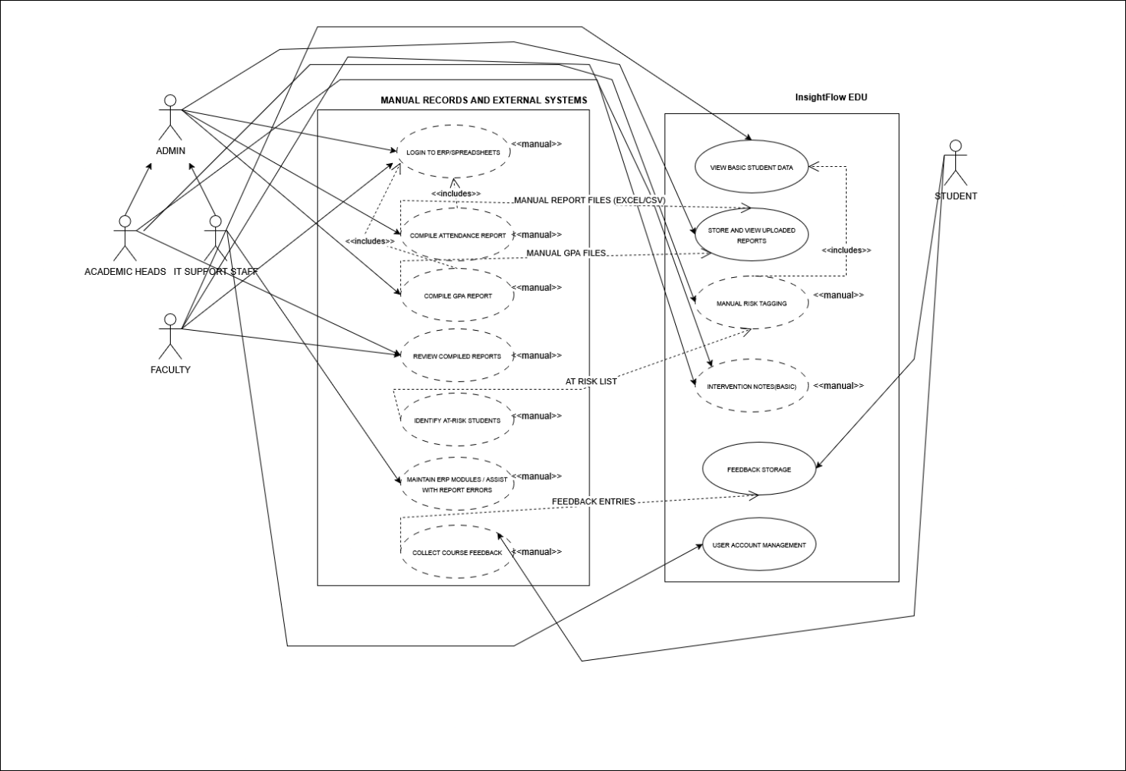
- AS-IS

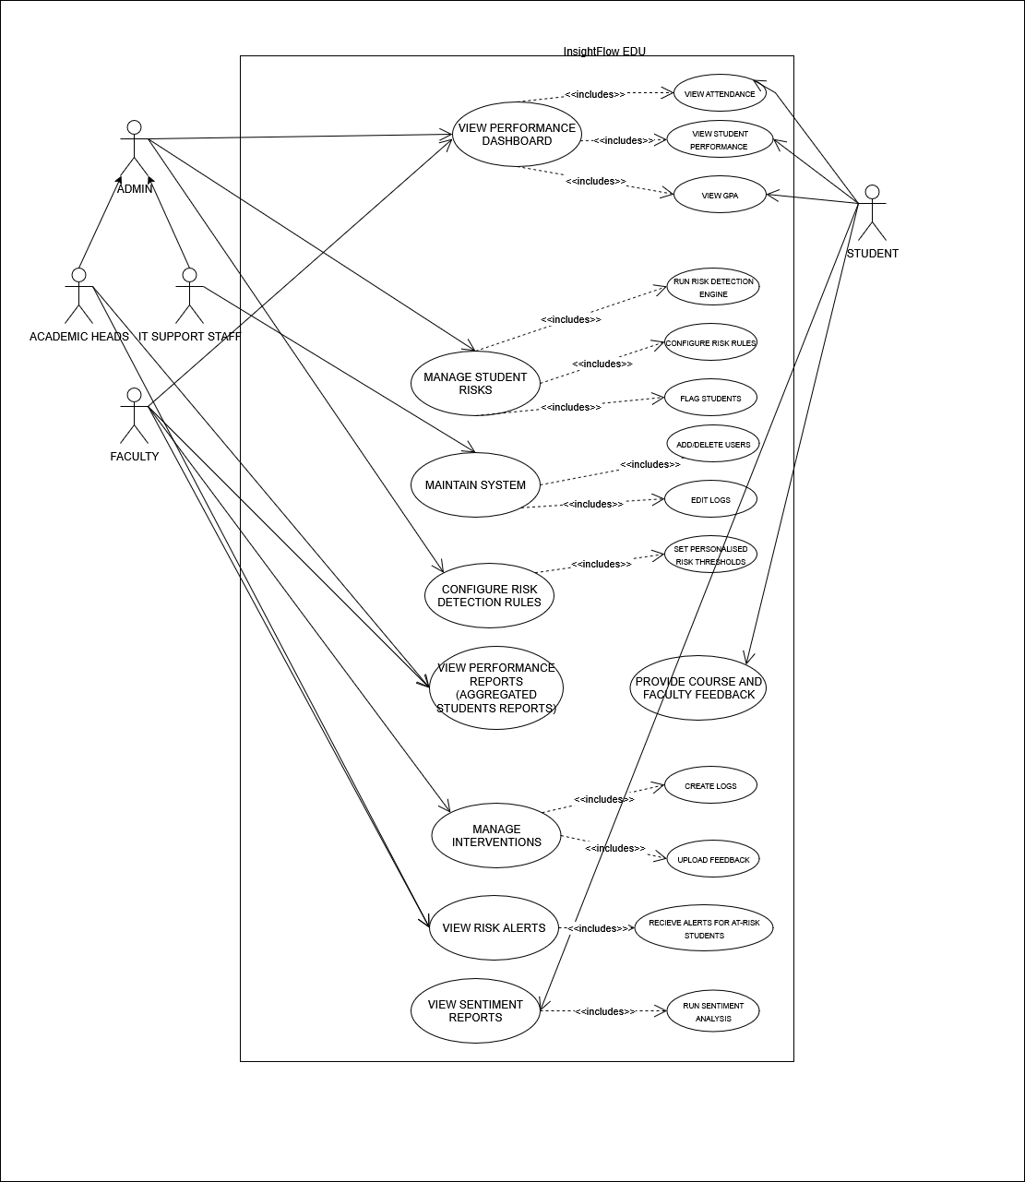
- TO-BE

- Class Diagram: Defines system objects and their relationships.
- Sequence Diagram: Illustrates flow of actions for key features.
- Activity Diagram: Maps workflows like risk detection and intervention logging
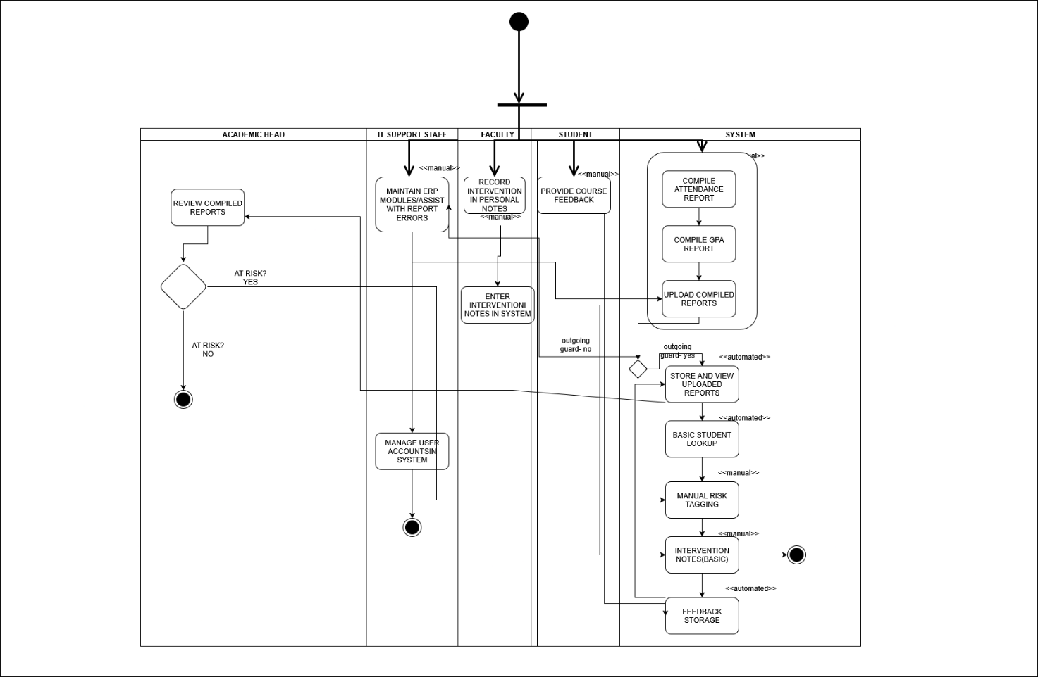
- AS-IS
- TO-BE

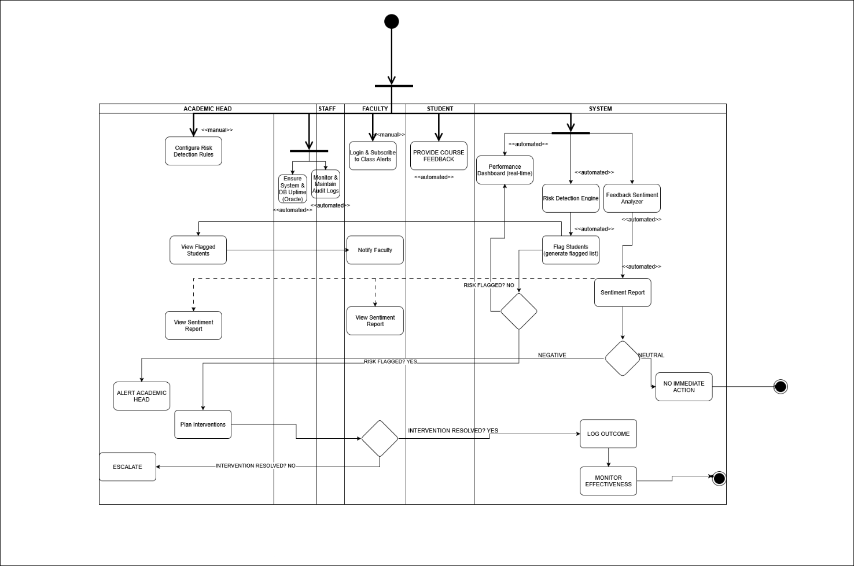
Appendix C: To Be Determined List
TBD ID | ITEM | EXPECTED RESOLUTION
TBD-1 | Final backend framework choice | Week 3 of development
TBD-2 | Integration with ERP systems | Phase 2 (future release)
TBD-3 | Sentiment keyword list | Week 6 of development
TBD-4 | Hosting environment (cloud/intranet) | Week 2 of development

